Transit of Mercury

Nov. 8, 2006
12:03.8 to 18:10:08.8 MST
The sun will set approximately 4 minutes before third contact.
Mercury will cross the disk of the sun from about 45 to 30 degrees south.
The next transit of Mercury will be Nov. 9, 2052, thus this is an important event.

1. Dunn Telescope at Sunspot

Observers: Dr. Rosemary Killen (UMd,) Thomas Bida (Lowell Observatory), and Dr. Keith Reardon (Observatorio Astrofisico di Arcetri, Italy)
Instrument: IBIS (Interferometric Bidimensional Spectrometer)
2-stage Fabry-Perot
5800 - 8600 A
80 arcsecond field of view
1024x1024 array
(F. Cavallini, Instrument Scientist)

2. McMath-Pierce Solar Telescope at Kitt Peak, Arizona

Observers: Andrew Potter (NSO) and Matthew Knight (UMd)
Supporting scientist: Claude Plymate NSO

Using the main spectrograph with a long slit, 20 mA spectral resolution
scanning across the disk of Mercury
will observe the sodium D lines and then calcium 4226

Observing Procedures

Our objective is to map the Na D₂ absorptions in the atmosphere of Mercury during the transit of Mercury across the Sun on November 8, 2006, using the IBIS instrument with adaptive optics on the Dunn telescope. The general procedure for this observation is to stabilize Mercury in the center of the 80 arc second field of view of the Fabry-Perot, and then to scan through the 5890 A sodium Fraunhofer line over a range of 2 A, stepping about 18 mA for each 1024x1024 image frame. Thus, we would expect to get about 100 images for each scan. We also need some scans of the Sun with Mercury just out of the field of view, in order to provide background spectra to subtract from those with Mercury in the field of view. A series of flat-field observations at various positions on the Sun will also be required. The transit of 2003 was observed by Schleicher et al. (2004), who used the TESOS 2-d Fabry-Perot spectrograph at the Vacuum Tower Telescope at Izana, Tenerife. After flat-fielding the images, we expect to follow the data processing procedure used by Schleicher et al. (2004), by which we locate the center of Mercury in each image, and then sample the counts in circles concentric with the planet. To improve signal-to-noise, we would average counts in azimuthal increments of 15 degrees, as described by Schleicher. In this way, we can build up spectra at various altitudes and azimuths above the surface of Mercury. The sodium absorption is determined by subtracting a spectrum with Mercury in the field of view from a reference solar spectrum. This is illustrated in the figure (from Schleicher et al. 2004), where the black line represents the reference solar spectrum, the red line represents the solar spectrum near Mercury, and the green line represents the reference solar spectrum shifted to match the red Mercury spectrum in the spectral wings (both red and green spectra have been smoothed). The orange region is the difference between the red and green lines, and represents the absorption of sunlight by sodium in the exosphere of Mercury.

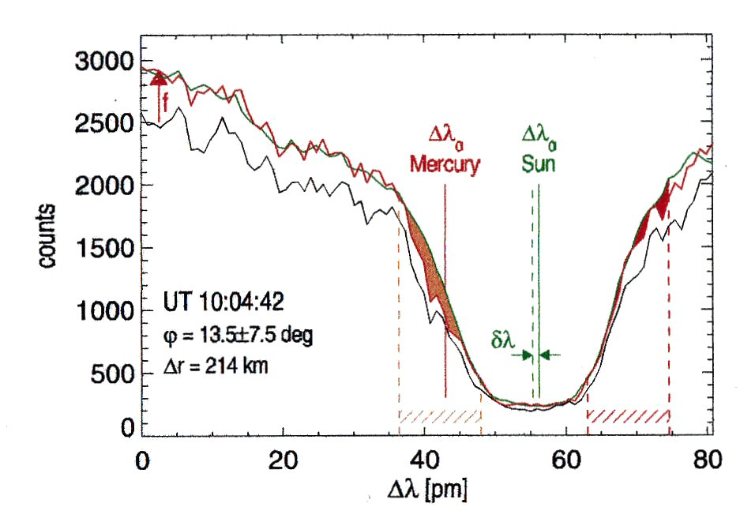

Figure 1. Profile of Na D2 above Mercury's limb observed by Schleicher et al. (2004) during the 2003 transit of Mercury.

Mercury transit will begin at 19:12:03.8 UT on 11/8/06 and end at 00:10:08.8 UT on 11/09/06, or 12:12:03.8 to 18:10:08.8 MST. The elevation of Mercury will be 38 deg. at ingress, but -2 deg at egress as seen from Sunspot. Although the full 5 hour transit will not be seen at Sunspot, Mercury is at 6 deg elevation at 4:32 PM. Thus about four and a half hours of the transit will be observable from Sunspot. We expect it would be best to complete the flat field observations well prior to ingress, and then begin Mercury observations as soon after ingress, when the elevation of Mercury is as high as possible. We require only one good set of scans for analysis. However, we should take as many as possible during whatever clear skies are available.

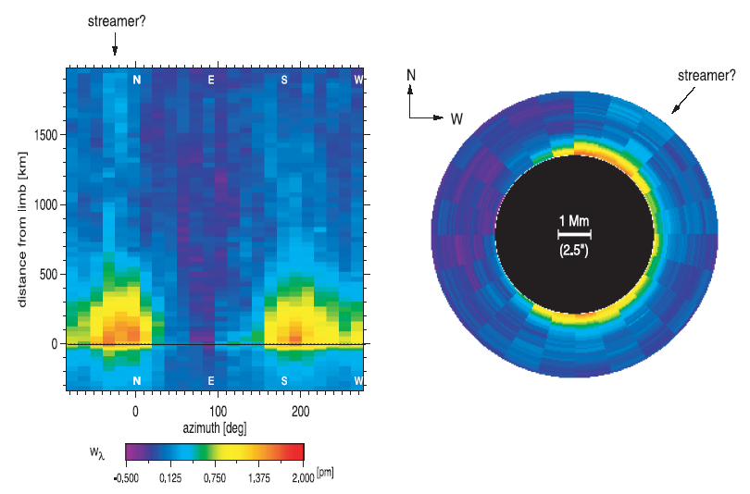
Distribution of sodium above Mercury's limb, May 7, 2003, observed by Schleicher et al. (2004) during the transit of Mercury.

Scientific Justification

The transit of Mercury on November 8, 2006, will provide a unique opportunity to observe that planet's tenuous atmosphere in absorption above the solar disk. Both the high spectral resolution provided by the IBIS Fabry-Perot 2-dimensional imaging spectrometer and the very high spatial resolution provided by the adaptive optics at the Dunn Telescope make this instrument ideal for this project. Mercury's sodium exosphere has been observed for many years (Potter et al., 2005), giving us many clues to its fascinating temporal and spatial variability. Because we are unable to observe the full disk at zero phase angle, we have never before been able to observe both the dawn and dusk limbs at the same time. Schleicher et al. (2004) obtained excellent observations showing the exosphere in absorption out to 700 km above the disk. The 2006 transit will not be observable from Tenerife. The 2006 transit will be the last opportunity to observe the sodium exosphere in absorption for a decade—the next pair of transits will not occur until May 2016 and November 2019.

During the 2006 transit, Mercury's angular diameter will be 9.97", nearly the largest it is ever seen from the Earth. The planet will be approaching perihelion, at a distance from the Sun of about 0.315 AU. The radial velocity will be about -5.2 km/sec, similar in magnitude, but opposite in sign from the transit of 2003. With a pixel size of 0.08", our resolution will be less than 50 km, or about one third of a scale height. This will give us unprecedented resolution of this elusive exosphere. Schleicher saw an excess of sodium emission mainly concentrated above the polar regions, and no excess on the duskside of Mercury. We intend to determine whether the polar excess persists, and whether an excess of emission exists at the dawnside relative to the duskside. Our previous observations indicate that there is about twice as much sodium at aphelion as at perihelion. Its intensity and relative distribution near perihelion are of great interest and also useful for planning data acquisition for the Messenger and Bepi-Colombo missions to Mercury. The polar enhancements of sodium in the Mercury exosphere are believed to be the result of solar activity, whereby solar particles are precipitated to high latitudes from the solar wind. We will look for correlations with solar parameters at the time of observation.
__________________________________________________________________________________

- Potter, A.E., C. Plymate, C. Keller, R.M. Killen and T.H. Morgan, Observations of Mercury's Na exosphere with Tip-Tilt Stabilization on the McMath-Pierce Solar Tesescope, Adv. Space Res., In press, 2005.

- Potter, A.E., R.M. Killen, and M. Sarantos, Spatial Distribution of Sodium on Mercury, Icarus, in press, 2005.

